Summer 2018 Application Packet

ssc.stanford.edu
Hey there, Applicant!
We’re glad you opened this packet—you are about to embark upon a bright, multi-colored adventure. We’re excited for you to begin your application and cannot wait to meet you! Before you start filling the spaces with your words and ideas, though, please take a few moments to read these pages. They’ll tell you some important information about Camp and the application process.
Each summer we hire 61 Stanford students to create a diverse and cohesive staff that is the heart and soul of Camp. If you are looking for a challenging environment where you can give yourself wholly to work and play, then you are likely to thrive at Sierra Camp. Whether you’re developing programs for kids, conversing with adults, sharing your unique passions, leading hikes, bussing tables, writing skits, or making beds—you’re there giving your all. There is no “ideal” staffer; we have no mold to fit. The unique contributions and background of each staffer make the magic of Sierra Camp. We sincerely hope this application process allows you to express the talents, perspectives, and experience that you would bring.
All applications are due by 5:00pm on Friday, January 12, 2018. Applications can be turned in at the front desk of the Frances C. Arrillaga Alumni Center or via e-mail to apply.to.ssc@gmail.com. The Alumni Center is open from 8:00am to 5:00pm, Monday through Friday. We will send you a link to sign up for your interview on Saturday, January 13th, after we've received all applications. First-round interviews begin Monday, January 15th and end Friday, February 2nd.Here is how the selection process works: all first-round applicants interview with two members of the Interview Committee (ICOM). About eighty first-round applicants are chosen to go on to the second-round interview pool, joining former staffers (usually 30-40) who are reapplying. Assistant Camp Director Leanna Castro and Staff Director Michael Kim will conduct the second-round interviews and have the final decisions confirmed in early March.

The optional character reference form is also due on January 12th. You can request a reference from a present or former employer/supervisor, Stanford faculty member, or former Sierra Camp Staffer who knows you well. While a reference is not required, it can give us further insight into your character and personal skill set. The person completing the form should drop it off at the Alumni Center or email it directly to apply.to.ssc@gmail.com.
Again, we look forward to getting to know you through both your application and your interview! If you have any questions, please contact Staff Director Michael Kim by e-mail, in person at the Alumni Center, or via telephone at (650) 721-1570. Also feel free to contact any member of the Interview Committee. We’re always looking for an excuse to talk about Camp!
Good luck and have fun!
The Interview Committee:
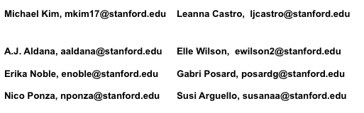

Job Descriptions
Individual Instructors: In general, these positions require instructors to develop and implement their own programs. While all staff members interact with children daily, leaders of these programs tailor their activities towards adults. Some of these jobs involve fewer program hours and can be combined to fit your interests. However, if it is considered a full-time position, you would spend your programming hours in this role and all non-programming hours doing miscellaneous jobs around Camp. For more information about these roles, please contact our Individual Instructor Coordinator Erika Noble at enoble@stanford.edu or Staff Director Michael Kim at mkim17@stanford.edu.
ARTS
ART INSTRUCTOR (1) The Art instructor mainly teaches art to adults and blends instructive points with engaging conversation. The Art Instructor should be competent in a variety of traditional media, but equally important qualities are a desire to take creative ownership of the program and an excitement for teaching. Programs in the past have included Paint and Sip, Charcoal Sketching, Art Boatster, and more! Pottery experience is preferred, as we are working on starting a ceramics program at Camp. This is typically a full position.
CRAFTS INSTRUCTOR (1) Love designing, creating, and teaching crafts? As the Crafts Instructor, you’ll get to share your love for creating while spending time with guests who have a passion for new projects. Crafts in the past have included Stained Glass, Batik, Basket Weaving, and Earring Making. We encourage innovation--make it your own! This can be a half position.
MUSIC/THEATER DIRECTOR (1) The Music/Theater Director directs the weekly a cappella performance for adult guests, directs a play with a wonderful cast of staffers, performs with other staffers at the Friday barbecue music hour, and plans fun music and theater education for kids’ groups. Patience, spunk, and a love for teaching are crucial. This is typically a full position.
IMPROV INSTRUCTOR (1) Got a flair for the dramatic? The Improv Instructor leads Improv workshops throughout the week for guests of all ages, and plays a major role in leading the weekly Improv show. Patience, an ability to work with both kids and adults, and a knack for thinking on your feet are a must! This is typically a half or quarter position.
SPORTS
ROCK CLIMBING INSTRUCTOR (1) This instructor is a climbing enthusiast who teaches guests of all ages safe climbing techniques on our rock wall, as well as on a nearby natural rock wall. Some past climbing experience is required and site belay certification is preferred, but this can be provided by Camp if necessary. This can be a half position.
SAILING INSTRUCTOR (1) This instructor teaches a variety of sailing clinics to adults and older children using Camp’s Lasers, Lidos, Bic Opens, Hobie Waves, and Hobie Cats. Knowledge of sailboat maintenance is preferred; a positive attitude, patience, and assertiveness in teaching guests in shifty winds are required. This is typically a full position.
TENNIS INSTRUCTOR (1) Having won Wimbledon is not as important as having high energy and a love of teaching. The tennis instructor runs clinics and tournaments for adults and kids throughout the week. This staffer is charismatic, enthusiastic, positive, a skilled ball-feeder, and can pull out a drill at any moment. A good sense of humor helps, too! This is typically a full position.
VOLLEYBALL INSTRUCTOR (1) Spending many hours in the sand, this instructor leads clinics open to all skill levels, focusing on putting the fun in fundamentals. The highlights of each week are the guest volleyball tournament and the staff vs. guest match; both are long-standing Camp traditions. The volleyball instructor must be able to generate hype for these competitive events and go the extra mile to increase participation. This is typically a half position.
MOUNTAIN/ROAD BIKE INSTRUCTOR (1) What’s more fun than whipping down a trail feeling the wind against your face while surrounded by classic Sierra mountain scenery? To pursue this amazing feeling, our guests have the option to rent a mountain bike for the week, and some even bring their own bikes to Camp. You’ll get to lead bike rides of various levels of difficulty. Mountain biking experience is preferred. The desire to make this program creative, fun, and unique is required. This is typically a half or quarter position.
YOGA INSTRUCTOR (1) From a serene deck overlooking Fallen Leaf Lake, this instructor guides guests of all levels and all ages in discovering yoga. Technical certification is not necessary, but the instructor should enjoy early mornings, have knowledge of several disciplines, and can instruct up to ten weekly hour-long sessions. This can be a half position.

OUTDOORS
NATURALIST (1) Weekly duties include leading an educational nature hike and other creative, nature-related activities for adults. Past Naturalists have focused their programming on wildflowers, local geology, bugs and insects, fire ecology, lake health, and eutrophication. Add your expertise to the list! This can be a half position.
HIKING LEADERS (2) The Hiking Leaders organize and lead three adult hikes of various lengths each week, and help guests plan and organize their own excursions in nearby Desolation Wilderness. These leaders will go the extra mile to make guests’ outdoor adventures unique, like bringing materials to enjoy chocolate fondue at the top of Mount Tallac. Wilderness First Aid certification is preferred, but not necessary. This is typically a full position.
KIDS' NATURALIST (1) Love learning about the environment and working with kids? The Kids' Naturalist will work with kids' group leaders to develop educational environmental programming that utilizes Camp's beautiful location. They will spend 2-3 hours per week with various kids' groups. This can be a half position.

Specialty Positions: These positions are unique in that they are associated with a specific place at Camp (the Ski Dock, the Kitchen, the Fountain, the Boat Dock, the Office). They are all important in creating a wonderful guest experience and strong staff community. If you have any questions regarding the Ski Dock position, feel free to contact our Ski Dock Head Austin Jones at austinhj@stanford.edu. If you have questions regarding the Office Assistant and Photographer positions, reach out to Individual Instructor Coordinator Erika Noble at enoble@stanford.edu. For more information about the other roles, please contact Staff Director Michael Kim at mkim17@stanford.edu.
SKI DOCK INSTRUCTORS (5) Do you have the patience that it takes to teach waterskiing and wakeboarding? Instructors help guests of all ages and skill levels to enjoy these sports and perfect their technique. How well you slalom is less important than your communication skills and attention to safety – you’ll interact directly with many families each day. Boat driving experience and boating license are preferred but not necessary. This is typically a full position.
KITCHEN CREW (6-8) Ah, the kitchen, or as most of Camp knows it, the Chicken...one of the most high-energy spaces at Camp. Walking into the kitchen, you can feel the love, the passion, and the energy it takes to create 1,000 meals a day. More important than culinary expertise is a positive attitude, a willingness to bring the heat, and a great playlist. The work is intense at times, but this intensity creates a tight-knit Chicken community. This is typically a full position.
FOUNTAIN SPECIALISTS (4) The Fountain Specialists work front and center in our Camp store where guests of all ages come to purchase apparel, SSC goodies, or grab a milkshake. While many staff will have fountain shifts, the Fountain Specialists are looked upon for guidance in operating the cash register, facilitating purchases, and maintaining overall customer satisfaction. The fountain is the perfect place to constantly interact with guests and staff! This is typically a half or quarter position.
BOAT DOCK COORDINATOR (1-2) The Boat Dock Coordinator is responsible for general maintenance of the Boat Dock and its vessels. Initiative, ability to take ownership, an eye for safety, and excitement about learning/refining skills like sewing, fiberglassing, and fixing are more important than extensive experience. This is typically a half position, so you’ll also have another job from the individual instructor or specialty position lists!
OFFICE ASSISTANTS (2) The office is the control center of Camp. The Office Assistants help write the daily information letter on what’s happening at Camp, answer phones, oversee guest check-in and check-out, create a friendly office environment, and answer any questions that guests or staff might have. Working in a central location means interacting with a lot of staffers, helping a lot of guests, and getting close to the office staff. This is typically a full position.
PHOTOGRAPHERS (2) Camp’s two Photographers capture the best moments of Camp each week using digital SLRs. They also take family portraits, communicate with guests continuously in person and via email, organize sales, and create an original slide show at the end of each week. An outgoing and positive attitude is essential, as well as detail-orientedness, diligence, and commitment to follow through on long-term projects. Some photography experience is preferred. This is typically a full position.

Kids’ Group Counselors: Camp provides organized children’s activities every day. Each Kids’ Group Counselor helps design a weekly program that’s exciting and entertaining. Activities should combine education and entertainment and may include hikes, games, arts and crafts, boating, storytelling, campfires, outdoor education, and anything else you can dream up. Prior experience working with kids is helpful, but not required. Creativity, flexibility, enthusiasm, and the ability to work well in a group are essential. All Kids’ Group Counselor positions are full positions, meaning they are not typically split with individual instructor or specialty positions. Kids’ Group Counselors spend all their programming hours with kids and all non-programming hours doing miscellaneous jobs around Camp. For more information about kids’ groups, please contact our Kids’ Group Coordinator Kady Richardson at kdrich@stanford.edu or Staff Director Michael Kim at mkim17@stanford.edu.
MUNCHKINS (4 counselors) Ages 3-4 These tiny tykes are adorable but unpredictable. They are playful and imaginative, but also require cuddling and flexibility when left without their primary caretakers. Munchkin counselors are storytellers, crayon artists, and imagineers who are patient and love little ones.
SNOOPERS (5 counselors) Ages 5-6 Snoopers are known for being active and wonderfully imaginative. These kids live for stories, wacky games, and entertaining counselors who want to be wild and spontaneous (just like the Snoops) in their programming. While these kids are of school age, they still require close supervision.
MENEHUNES (5 counselors) Ages 7-8 Here’s a quote from a famous cheer: “Menehunes! We’re so loony!” These kids are energetic and curious about their surroundings and have an easier time being separated from their parents than they do from their counselors. If you prefer a certain amount of organized chaos in your daily life, the Hunes could be for you.
YAHOOS (5 counselors) Ages 9-10 These youngsters have a seemingly endless supply of energy and are quick to make their presence known around Camp with loud and crazy chants. Yahoos love hearing stories, figuring stuff out, and learning cool things, but most of all, they enjoy having counselors who are willing to listen and converse with them.
MIDOREES (5 counselors) Ages 11-12 Midorees are an awesome balance of energetic kid and budding adult. They still enjoy the silly side of things but are old enough to begin doing more challenging activities. They sometimes pretend to know it all, but don’t be deceived – they are impressionable and truly value learning from and with their counselors. And you can bet they’ll make it their mission to find out what counselor you’re “dating.”
SUAVES (4 counselors) Ages 13-14 Suaves are super cool and social (or at least trying to be). They love getting to know each other and their counselors, but the challenge is to get them to develop deeper friendships and encourage them to try new things. Read a teen mag or two to brush up on your pop culture and get ready to be a role model. Each week counselors will organize and facilitate a fun, educational, and activity-filled overnight backpacking trip for the Suaves. Wilderness First Aid Certification is preferred.
TEENS (4 counselors) Ages 15-18 Teens love having down-to-earth counselors that can entertain and really get to know them as young adults. These older kids go sailing and waterskiing and engage in creative, team-building challenges that vary from year to year. Each week counselors will organize and facilitate a fun, educational, and activity-filled overnight backpacking trip for the Teens. Get ready to be a friend and mentor to these forward-thinking teens. Wilderness First Aid Certification is preferred.

NEW AND COMBINED PROGRAMS SSC is an outdoor classroom where alumni and their families engage in the interests of our staffers. As the teacher, what new programs would you host? Many of these instructor roles were born of new staffers’ desires to teach something they were passionate about. Create your own position and tell us about it; we’re always looking for innovation! In the past staffers have also split their weekly hours between multiple positions, such as spending time as the improv instructor as well as leading crafts.
Additionally, even if there isn’t enough demand to create a whole position, the guests love it when staffers create new programs in their areas of interest. Past programs have included fly fishing, rowing clinics, astronomy/ stargazing, book discussions, dance classes, design thinking brainstorms, espresso tastings, and creative writing workshops. Camp is a place to share your passions with others!
Camp Information
For more information on the Stanford Sierra Camp experience, check out ssc.stanford.edu.
Stanford Sierra Camp is a facility operated by SAA-Sierra Programs, L.L.C. for Stanford alumni families, faculty, staff, and friends. It is located on the south shore of Fallen Leaf Lake, nestled between Desolation Wilderness – a spectacular national wilderness area with ample hiking opportunities – and beautiful Lake Tahoe. The lifeblood of Camp is its student staff: 61 diverse, dynamic, and dedicated individuals who ensure that during each of Camp’s 12 one-week sessions, the approximately 300 guests have the time of their lives.
• Compensation for the 12-week season, in addition to room and board, is approximately $9,000 before taxes (a weekly salary of $320 plus weekly tips from guests).
• Camp has 61 positions, which all require passion, a positive attitude, and a strong work ethic.
• Staffers are scheduled for an approximately 48-hour work week that spans about 5.5 days.
• Everyone gets 1.5 days off per week. Time off beyond your 1.5 days is allowed only for emergencies. All staffers commit to work the entire 2018 summer season.
• All staffers must attend the Spring Orientation Weekend, tentatively set for May 4-6, 2018.
• Summer runs from June 16 - September 10. Staffers must arrive at Camp after final examinations end on Wednesday, June 13th, to begin orientation on Thursday, June 14th. Graduating seniors must arrive at Camp on Monday, June 18th, after graduation.
• At the end of the summer, from September 8-10, Sierra Camp runs a Kids Camp for 5th grade students from East Palo Alto Charter School. As staff are paid for this weekend, we expect everyone to stay for it unless they need to return to school for RA positions or other approved commitments. Many staffers have said that this weekend was the most rewarding part of their whole summer!
• Staffers eat meals with guests daily (excluding off days); it’s a great time to establish friendships and alumni contacts through conversations about anything and everything.
• About half of your scheduled hours are spent on your specific program and half are spent working other jobs (e.g. meal shifts in the dining room, dish-washing on a Hobart shift, leading egg toss on Games Day, etc.). Individual instructors of adult programs usually work more than half of their scheduled hours in non-program areas.
• Camp is located about a half-hour’s drive away from the nearest town – South Lake Tahoe, CA.
• Staffers live closely together in rustic cabins. (The lakefront location and view make up for the tight
quarters.)
• At least 5 hours every Saturday are spent cleaning cabins. Everyone gets a chance to scrub toilets, make beds, and get stoked for HOUSEKEEPING MEETING!
• A combination of CPR, First Aid, Lifeguarding, Boating License, and CA Food Handlers certification are required, depending on your position. We will arrange and pay for these classes during spring quarter for people who are not certified. If you opt not to take the courses arranged for you, then you must complete them on your own.
Sample Day’s Schedule
All staff participate in Saturday morning cabin cleaning, one all-staff meeting, one team meeting, and the introductory meeting (where each staffer group performs a skit for the guests) each week. Other shifts during the week vary from staffer to staffer, but everyone has plenty of opportunities to meet guests and enjoy time off.
Below is a typical day’s schedule (in this case for A.J. Aldana, Munchkins counselor). Note that in addition to A.J.’s time with the Munchkins (3-4 year olds), his day also includes a Hobart shift (with a partner and a sweet themed playlist, washing dishes has never been so fun), hosting a book discussion on For the Time Being with guests (who read the book beforehand), and working in the dining room for dinner service.
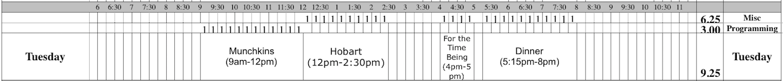
Each Staffer also gets a full day and a half off each week. Possible activities for you and your off-day crew are as limitless as your imagination and energy level!
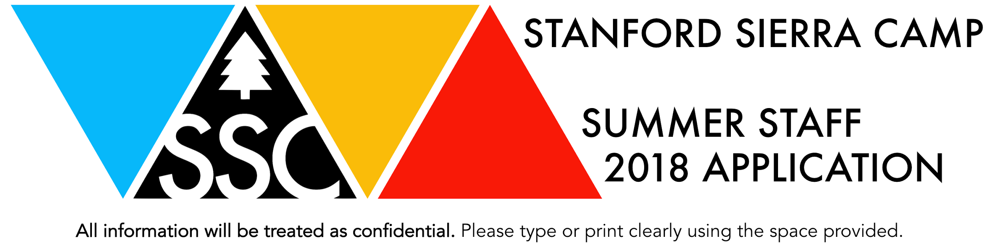
Name: ________________________________________________________________________________
Last First Preferred Name Pronouns

Local Mailing Address: _______________________________________________________________
Street/Box City State Zip

Permanent Address: _________________________________________________________________
Street/Box City State Zip

Campus Residence and Room Number: _____________________ Phone/Cell: __________________

Class Year: _________ Hometown: ________________________________

Major/Anticipated Major: ____________________________

E-mail Address: _________________________________

Using the job titles below (descriptions above), list up to five jobs (in order of preference) for which you’d like to apply. On the right, please tell us why you are excited about that position and what, if applicable, relevant skills or experiences you have. Feel free to list new program ideas for existing positions or ideas for new positions on this table as well.
Job Relevant Skills and Reasons for Applying
1.
2.
3.
4.
5.

Please fill this box with any other jobs you would have interest in working (optional):

Job, Activity, Experience Name | Duties Performed | Dates Worked | Name and Phone Number of Supervisor (if applicable)

List and briefly describe up to three of the most meaningful and/or relevant jobs, extracurricular activities, or experiences you have spent significant time on over the past several years.

There is no mold for the “perfect” staff member. We are looking for a diverse group of students with a wide variety of interests, personalities, and backgrounds. The most important thing to remember is that your answers are our chance to get to know you, so respond thoughtfully, completely, and be yourself. Feel free to respond with approximately 150 words, 2-3 pictures, an interpretive dance, or whatever else you can think of. We hope you enjoy filling this application out as much as we enjoyed writing it!

- Please list 14.5 things that are important to you. Awesome! Now underline your top six. Cool! Now choose one and tell us about it.

- Teamwork makes the dream work!
  - Who would be your partner if you were to be part of a Dynamic Duo, and why? It could be anyone (historical figure, fictional character, imaginary friend, etc.)! What would make you good partners and how would you complement one another?

  - Working together can be difficult at times. Tell us about a conflict you’ve had while working on a team. How did you respond?

- Whether you are clearing dishes, scrubbing toilets or consoling a crying child, Camp is hard work. Please tell us about a time you motivated yourself to work through a difficult task.

- Free Space! What? Sweet! Use this space as you please.

- Many of us have personal narratives that do not directly fit into an application question. Explain one of these narratives and how it could add to the Camp community.

Did you know hermit crabs have ten legs, but only six of them show? YES / NO (circle one)
Just thought you should know if not...

- You can’t stop smiling. What did you just do?

- One of our favorite parts about working at Camp is interacting with Stanford alumni and their families. What would you be most excited to talk about with guests?

- There are many opportunities to create at Camp – whether that be programming, friendships or memories. If you could make up a new word what would it be? Please define it, and use it in a sentence.

And finally, we must ask for your autograph and some informational details...and while this is technically for legal purposes, you should know that we plan to keep your signature on file, so that when you are famous, we can say “we knew you when...” and auction your autograph on Ebay.

If a conditional offer of employment is extended and accepted by the applicant, successful completion of a live scan is a required condition of employment. All live scan results will be sent to and reviewed by qualified personnel. Should a criminal history exist, an individualized assessment will take place to determine whether the applicant’s conviction history has a direct and adverse relationship with the specific duties of the job that justify denying the applicant the position. In making this assessment, the following will be considered, (1) the nature and gravity of the offense or conduct, (2) the time that has passed since the offense or conduct and completion of the sentence, and (3) the nature of the job held or sought. By signing below, you are acknowledging and agreeing to complete a live scan and undergo a criminal background check if a conditional offer of employment is extended and accepted.
I certify that statements made on the application, on a resume, attachments hereto, or other supplementary materials provided by me are full and complete statements of the facts. I understand that false, misleading or omitted information can result in refusal of employment or termination in cases where erroneous information is discovered after employment has begun. I understand that if I am offered employment and accept, this employment application form becomes part of the terms and conditions of employment. I understand that employment is contingent on supplying of documents for Employment Eligibility Verification.

Applicant’s signature ________________________________________ Date _______________ Persons with disabilities requiring accommodations for interviews may direct their requests to the hiring department at the time an interview is scheduled.

Whew!

Thank you for completing this application - you’re a rock star! We’ll see you soon. Oh, oh yes, one more thing…

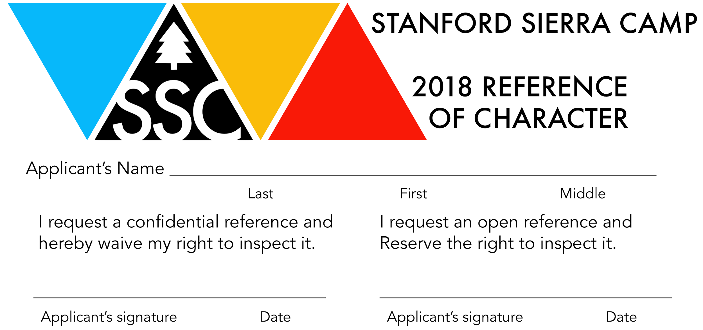
Stanford Sierra Camp is a family summer camp operated by SAA-Sierra Programs L.L.C. for Stanford alumni families, faculty, staff, and friends. It is located on the shores of Fallen Leaf Lake, near Lake Tahoe, CA.
Work at Sierra Camp is demanding. Some things required of all staff members include:
• working responsibly with little supervision
• performing consistently even when tired, or when work is uninteresting or repetitive (e.g., cleaning cabins or doing dishes)
• social and intellectual contact with adult alumni guests
• getting along well with sixty other student staffers in cramped quarters
• initiative in designing and implementing new programs

Character references are a valuable source of information in evaluating applicants. Please respond honestly to as many of the following questions as you feel qualified to answer given your knowledge of the applicant. If you have any questions about the nature of the job, please contact Summer Staff Director Michael by phone at (650) 721-1570 or e-mail at mkim17@stanford.edu. Please sign on the reverse side of this form and mail, e-mail, or fax it to the address below by January 12th, 2018.

- How long and in what capacity have you known the applicant?

- Please describe a situation in which the applicant has shown responsibility, initiative, and/or creativity.

- In addition to specific assignments in recreation programs and other scheduled hours, staff members must interact socially and intellectually with Camp’s guests and, more frequently, with other student staffers. How will the applicant perform in such interactions? Please provide any relevant examples.

- Every staff member does a fair amount of “grunt” work such as bussing tables, cleaning cabins, and washing dishes. How does the applicant react to this type of work and what attitude may we expect toward it?

- Anything you would like to add about the applicant?

Thank you for completing this form. Please fill out the information below.
Name: __________________________________________
Position: _________________________________________
E-mail: __________________________________________
Phone Number: ___________________________________
Signature: ________________________________________ Date: ______________

Submit by January 12th:
Mail or Drop Off: Fax: (650) 723-7543 Email: apply.to.ssc@gmail.com
Stanford Sierra Camp
Attn: Michael Kim
Frances C. Arrillaga Alumni Center
326 Galvez St.
Stanford, CA 94305-6105

